|  |
| --- |
| **INFO 3305 SEMESTER 1 2019/2020** |
| **PROPOSAL FOR PROJECT DEVELOPMENT**  **RESTAURANT MANAGEMENT SYSTEM**  **AL-FARAWILA**  **SITI NUR AISHAH BINTI ZAHARI 1622420**  **NURUL AMIRA BINTI ABDUL HALIM 1719162**  **FATDZIRATUL AFIQAH BINTI ABDUL RADZI 1627808**  **ANISSA MAISARAH BINTI MUHAMAD KHAIRI 1625318** |

**1.1 INTRODUCTION**

Restaurant Management System is a system that provides service facility to the restaurant. This system will help restaurants to maintain the catalog for the list of food and drinks provided. The service provided by this system are food ordering, table reservation management, customer information management, menu information management and report.

Most small growing restaurants are currently using the traditional pen and paper methods to take orders. For example, a waiter will take orders from customers and write it on a piece of paper. That order will then be passed to two sections that is the cashier and the kitchen chef. This process itself is time consuming and inefficient. As such, there needs to be an app to ease this process.

With this system, employees will be able to take orders and the order will be kept automatically to the cashier and kitchen sections. The total payment for the order will be calculated automatically. Other than that, employees will be able to add and delete the list of menus from catalog and help customers easily find available tables.

With this restaurant management system, ordering and reservation management will become easier and systematic.

**1.2 OBJECTIVE**

The objective of Restaurant Management System:

1. The management of the restaurant will be more systematic and efficient.
2. To introduce more user-friendly in the process for ordering, reserving table and billing.
3. To keep the update (add and delete) of the system.

**1.3 FEATURES AND FUNCTIONALITIES**

**1.3.1 Ordering system**

In this system, employees will be able to view the latest menu and select the menu depending on the order taken from customers. It also contains price of each item ordered which will be forwarded to the payment management system.

**1.3.2 Table management system**

Table management system will display the list of available tables for new customers to be seated. Employee will be able to organize the customer’s table depends on how much people sitting at a table. When order comes in, the table will automatically not available to other customers. The table will be back available when payment has been made.

**1.3.3 Payment system**

The system will calculate the total value for the ordered food and drinks. Any discounts extra service charge will also be calculated. After payment has been done, the system will generate receipt.

**1.3.4 Menu**

Menu system will manage upload, edit and delete of the menus.

**1.4 MODELS, VIEWS, AND CONTROLLERS**

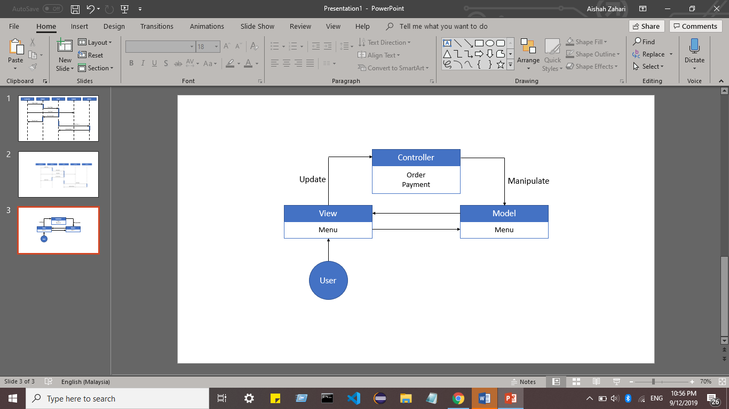

*Figure 1 – Models, Views, and Controller Diagram for Restaurant Management System*

**1.5 SEQUENCE DIAGRAM**

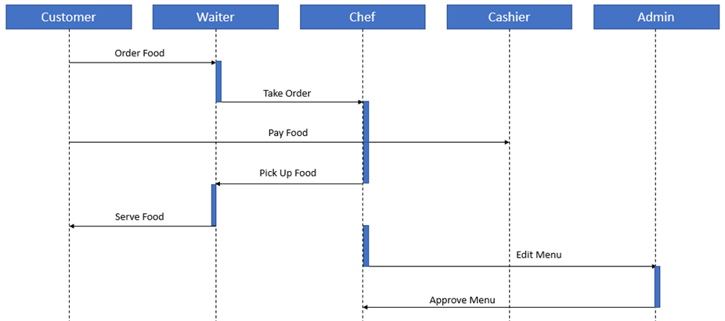

*Figure 2 – Sequence Diagram for Restaurant Management System*

**1.6 REFERENCES**

* + - 1. Sam. Top 18 Database Projects Ideas for Students. Retrieved from <https://www.lovelycoding.org/2013/11/top-18-database-projects-ideas-for.engineering-bca-mca-btech-bsc.html>
      2. DOCUMENTATION FOR AN ONLINE RESTAURANT MANAGEMENT SYSTEM. (n.d.). Retrieved from researchClue.com: <https://nairaproject.com/m/projects/3197.html>